**Our Facilitators:**

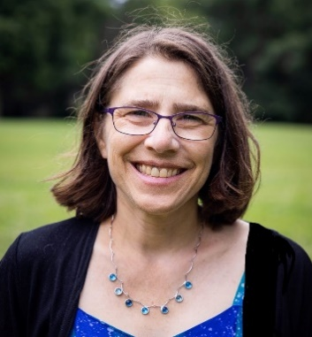**Lynn Rosenbaum, M.Ed., M.A**. has been enthusiastically facilitating Our Whole Lives for the past ten years to young people in grades 5-12 in Cambridge and surrounding towns in both church and community settings.An experienced Health Educator, she has led workshops on a wide array of topics including mindfulness, substance abuse, sexual assault, and eating disorders. She co-authored the chapter on Sexuality in *Our Bodies, Ourselves (2005)*and works with the Community Engagement Team in Cambridge. Lynn is also a musician and dancer, and a leader of improvisational CircleSings.

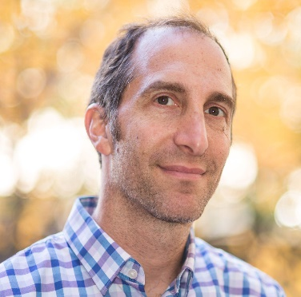**Stephen Garschina-Bobrow** is a father, educator, and musician who believes strongly in community. Since OWL training in 2012, he has taught OWL for 5th/6th and 8th/9th grade students in Belmont, Medford, and Arlington. A former high school Math teacher, Stephen now works as a district administrator for the Boston Public Schools to support teachers and school leaders. He has three young adult daughters (11, 18, and 22) who all went through the OWL program and is married to a public high school teacher. He works towards a more equitable world, loves to build useful objects and plays the trombone and guitar.