SLATE OF CANDIDATES
The Governing Board’s Governance Advisory Committee is pleased to present our 2024 – 2025 Slate of Candidates to run for open seats on the Governing Board. Candidate statements appear below. Elections will take place at the Annual Meeting on Sunday, June 9, 2024 at 12:30 pm. Everyone is invited to participate in the meeting although only voting members will be allowed to vote.
The Governance Advisory Committee called for nominations and self-nominations in February and has sought to develop a slate that would foster diversity and broad representation from our membership. We spoke with interested candidates to be sure they were fully informed of the duties of the position and able to commit to service. Candidates for these positions have learned about the responsibilities by conferring with members of the board. The board was notified of proposed nominees and approved the proposed slate.
The following slate of candidates along with candidate statements provide background information about their commitment to First Parish. We believe that these candidates share our passion for the mission of First Parish
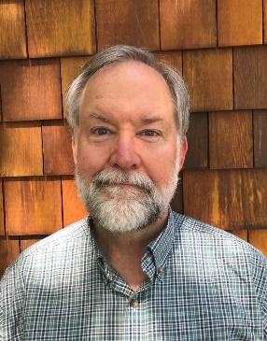
Tod Hibbard
Chair of Governing Board – One Year Term
I was raised Catholic, and that early experience of being asked by authority figures to believe things that couldn't possibly be true put me off organized religion altogether. Years later, when my wife Cynthia and I had children of our own approaching school age, we decided they needed a religious education - if only for their cultural literacy. But it had to be one that was open-minded and inclusive. Neither of us had been raised Unitarian Universalist, but it seemed like it might be a non-toxic environment for the kids; so we visited our local UU church, and found a nurturing, sustaining community both for our children and for us. We ended up teaching in the cooperative RE program, which our kids attended before going on to flourish in the active youth group there. I organized the annual church auction and the annual oriental rug sale and served as chair of the finance committee, chair of the annual all member canvass, chair of the standing committee, as a member of the bequest society and as auditor. Cynthia chaired the welcoming committee and was a member of the ministerial intern committee. We were members of that congregation for twenty years until, as empty nesters, we moved back to Cambridge (where we had met in college 40 years earlier).

Professionally, I am retired after a long career in banking and finance, most recently as head of treasury operations at Tufts University. Since joining First Parish in 2018, I have served as one of First Parish’s liaisons to the Greater Boston Interfaith Organization (“GBIO”), as chair of the Finance and Development Committee, as a member of the Building Advisory Committee, the Investment Committee and the Governance Advisory Committee, as an at-large member of the Board and currently as vice chair of the Board. I am honored to
have been nominated to serve as chair of the Board and, if elected, I hope to continue to bring my experience, perspective, and energy to our shared work of nurturing, supporting and sustaining our First Parish community and its work in the larger community.

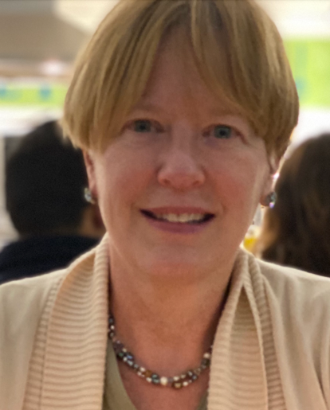
Julie Duncan
Vice Chair- One year term
I have been a member of First Parish for 20 years, beginning shortly after my husband and I adopted our daughter Chloe. Like many parents, I volunteered with the Religious Education program, serving on the RE committee and as a teacher. I have also served as a member of the Governing Board (at the time the Standing Committee), Welcome Team, and the Slave Legacy Working Group. I am most proud of my work with Beyond Borders-Sin Fronteras and our efforts through the Cambridge Interfaith Sanctuary Coalition in support of a family living in sanctuary in Harvard Square. I will bring my experience working on social justice issues and developing relationships with neighboring faith communities to bear in the role of Vice Chair.

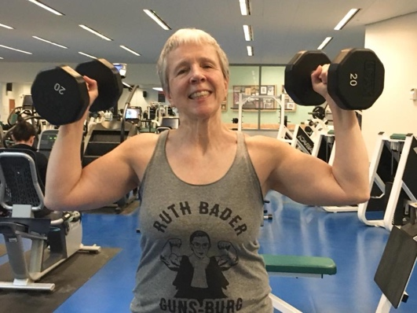
Jane Stabile
Treasurer – Two year term
I have been a member of First Parish since 2016 and of the Board for three years. I am also one of the Lay Worship Associates and a member of the Finance and Development Committee.

I have an MBA with a concentration in Health Care Management. I worked in Hospital Administration, and then for 20 years I ran a solo income tax service as an Enrolled Agent.

I am especially dedicated to maintaining and strengthening our sense of community. First Parish is its members. We need to strengthen our connections with each other.

Our congregation has had a lot of highs and lows in the last few years. We suffered from Covid, the loss of several important staff, and a lot of building issues including a collapsed ceiling and massive water damage. Now we are growing in all directions. Attendance at services is up, and many people attend electronically. The children’s programs are growing and changing, and so is the music program. The building has been strengthened and beautified. Our membership is growing.

And as a candidate for Treasurer, I should mention the finances. This year’s Stewardship Drive achieved our ambitious goal of $315,000. Our Endowment has been managed carefully over the years, so that we have a big cushion to protect our future. We are in excellent condition and my goal as Treasurer will be to work with the rest of the Board and the Staff to keep us on that steady course.

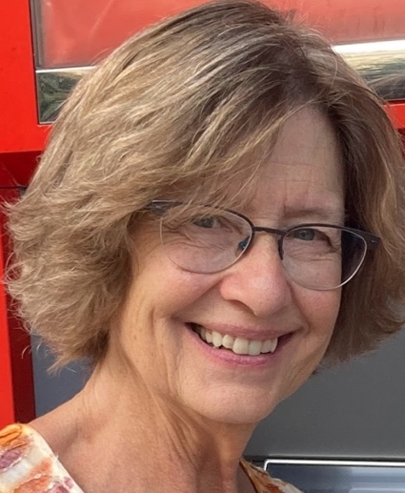
Lindsay Lucke
Member-at-Large – One year term
I am a relatively new member of First Parish, having moved to Somerville to join my daughter and her family after decades in Washington DC.

I am so excited about the growth and success of our congregation as we recover from the Covid debacle. It is awesome how far we have come. My granddaughters are enjoying the nursery and the religious education program. As we look toward an even fuller future, I personally am looking forward to singing with Jen during the next church year.

After serving as treasurer for two years, I am ready to step back and hold an at-large position on the Board. It has been a challenge to learn the full financial structure of this congregation, and I will help the new treasurer in every way I can. I want to be part of rebuilding the structures that will enable us to continue to blossom as a vital part of the Cambridge community and the community that is our world.

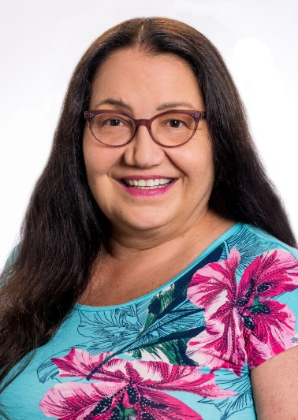
Nina Lytton
Member-at-large – Two year term
I am honored to have been invited to join the Board of First Parish. I began attending First Parish in September 2018, while I was a student at Meadville Lombard Theological Seminary. I formally joined the congregation in 2019 because I saw the people of First Parish doing the work of my kind of faith. At First Parish, I have participated in the Beloved Conversations program and served on the Racial Equity Team, the Strategic Planning Committee, and the Governance Advisory Committee. As we look forward to the 400th anniversary of our church in 2036, I am particularly interested in the early history of First Parish, especially the indigenous history.

Ministry is “act two” for me, a call that came after a career in high tech and a midlife detour in microbrewing in Hawaii. While I was on the Big Island, I became a student of, then served as an apprentice to a Hawaiian spiritual teacher, the late Mahealani Kaiwikuamookekuaokalani. My moral philosophy and spiritual tradition come from my Kumu’s Hawaiian tradition, and I am an ally of the unceded Hawaiian kingdom. My ethnicity is European settler and Native American.

I was recognized as Humanist Chaplain and Celebrant after I graduated from seminary in 2019. I served as an interfaith chaplain at Brigham and Women’s Hospital for a two-year period that spanned the first wave of COVID-19. Since 2021, I have been serving as an interfaith chaplain at MIT, where I work a lot of nights and weekends. I support the Addir Interfaith Dialogue Fellowship and, as acting director of the Radius Program in Technology and Ethics, I support the student activists. I serve the indigenous students at MIT and I am a mentor to MIT’s First Nations Rocket Team. I also serve the MIT community as a celebrant of interfaith weddings and memorials.

