First Parish in Cambridge
First Church, Unitarian-Universalist
Special Meeting - March 19, 2017

Members are notified that the Semi-Annual Meeting of the members of the Parish and Church will be held March 19th, 2017 at noon in the Meeting House.

The agenda:

FIRST: | Choose a Parliamentarian
SECOND: | Choose a Moderator
THIRD: | To vote on a proposal to restate and amend the First Parish in Cambridge bylaws
FOURTH: | To vote to dissolve First Church in Cambridge (Unitarian Universalist)
FIFTH: | To join in a Sanctuary covenant with other Harvard Square churches
SIXTH: | Transact any other business that may legally come before the meeting

On behalf of the Standing Committee and in accordance with their vote on February 21, 2017.

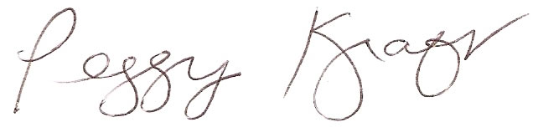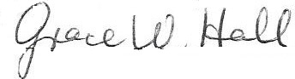
Peggy Kraft | Grace Hall
Chair, Standing Committee | Clerk, Standing Committee

Childcare will be provided during the meeting. All voting members can check-in at the beginning of the meeting and receive voting cards. Whether or not you’re eligible to vote, you are welcome to attend the meeting and participate in discussion. If you are not a voting member, we encourage you to join our congregation and fully participate – contact Membership for information about joining First Parish.
A vote is planned for this meeting. Voting members need to have officially joined First Parish and need to have made a financial contribution of record within 12 months of the meeting. If you are unsure of your status, contact Carol Lewis or call 617-876-7772 by March 17. Only voting members will receive voting cards.
Handouts and other information related to the agenda can be found on our website: http://www.firstparishcambridge.org/meeting. Please review this information before the meeting. Our congregation is a democracy, which depends on each member’s voice and vote. Please join us on March 19th at noon.

