First Parish in Cambridge
First Church, Unitarian-Universalist
Fall 2016 Semi-Annual Meeting

Members are notified that the Semi-Annual Meeting of the members of the Parish and Church will be held on November 6th, 2016 at noon in the Meeting House.

The agenda:

FIRST: | Choose a Parliamentarian
SECOND: | Choose a Moderator
THIRD: | Hear a report on Y2Y
FOURTH: | Hear a report from Standing Committee, Minister, and Director of Religious Education on the Vision of Ministry for 2016-2017
FIFTH: | Hear a report on the Goals of the Interim Ministry for 2016-2017
SIXTH: | Hear a report from Buildings and Grounds and Finance on the capital improvement projects
SEVENTH: | Hear a report on the governance changes by the Governance Working Group
EIGHTH: | Hear a report from the Search Committee
NINTH: | Receive the 2015-2016 Annual Report
TENTH: | Transact any other business that may legally come before the meeting
On behalf of the Standing Committee and in accordance with their vote on October 18, 2016.

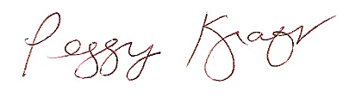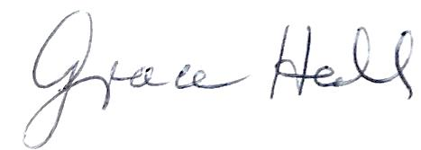
Peggy Kraft | Grace Hall
Chair, Standing Committee | Clerk, Standing Committee

Childcare will be provided during the meeting. Lunch will be for sale prior to the meeting and proceeds will benefit The Youth Group.

All voting members can check-in at the beginning of the meeting and receive voting cards. Whether or not you’re eligible to vote, you are welcome to attend the meeting and participate in discussion. If you are not a voting member, we encourage you to join our congregation and fully participate - contact Membership@firstparishcambridge.org for information about joining First Parish.

Voting members need to have officially joined First Parish and need to have made a financial contribution within 12 months of the meeting. If you are unsure of your status, contact Carol Lewis, at office@firstparishcambridge.org or 617-876-7772 by November 4. Only voting members will receive voting cards.

Handouts and other information related to the agenda can be found on our website: http://www.firstparishcambridge.org/meeting. Please review this information before the meeting. Our congregation is a democracy, which depends on each member’s voice and vote. Please join us!

