We focus our funds
to support our mission.

Imagine more of what you love about First Parish
- More music
- Better accessibility in our building
- Ample support for our teachers
- New social justice initiatives
- Additional community building activities like Ferry Beach
OUR MISSION
Awakened by worship,
nourished by tradition,
and united by love,
we strive to create a multicultural,
spirit-filled community
that works for justice,
fosters spiritual curiosity
and faith formation,
shares joy, heals brokenness, and celebrates the sacred in all.

2015-2016 Annual Budget Drive
February 22, 2015 -March 14, 2015

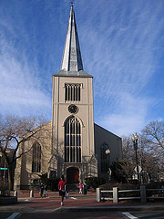

For questions email the Stewardship Committee at:
stewardship@firstparishcambridge.org

Contact the church office:
617-876-7772

Stewardship Team:
Claryce Evans, Steve Hanna,
Karin Lin, Susan Shepherd,
Don Tucker, Linda West

First Parish in Cambridge
Unitarian Universalist

Where

You are loved

You are free

You are called

2015-2016
Annual Budget Drive

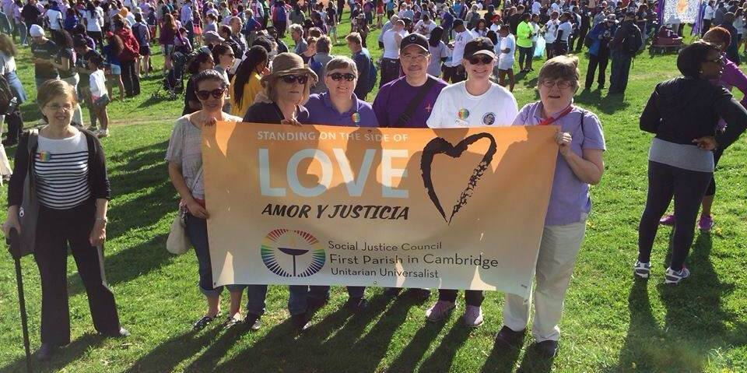
We support First Parish because its mission speaks for us and we believe it rings true for making a difference in our own congregation, our surrounding community, and our world. We share a commitment to the ministry and programs of First Parish and believe in the transformative effect we can have on the pressing needs of today.

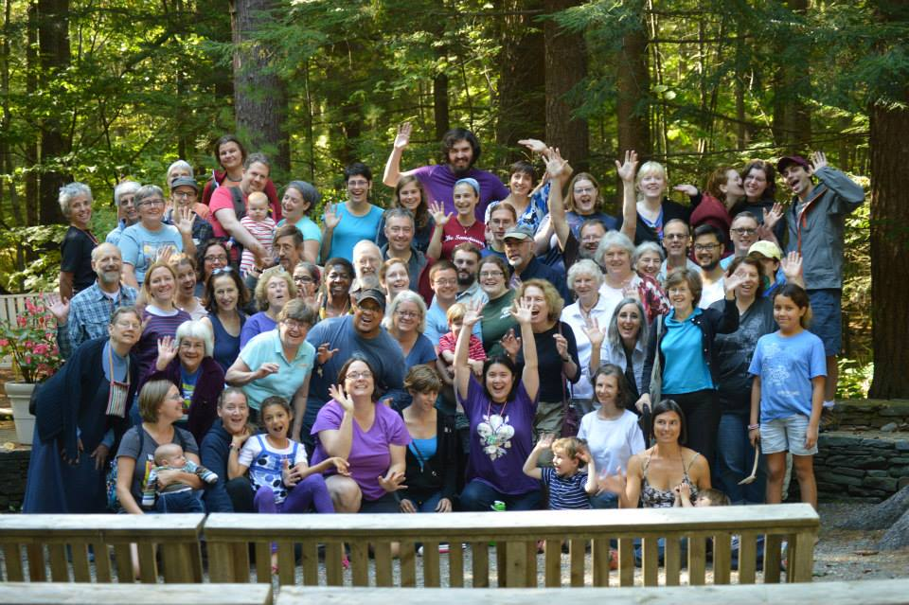

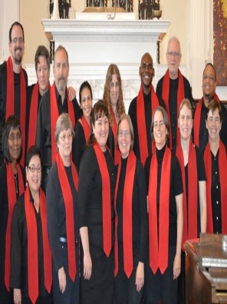
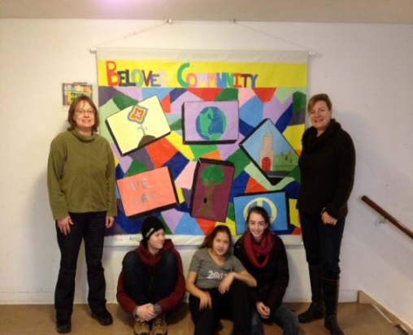
Each year we commit anew to supporting our mission through our annual budget drive. Fair share giving is congruent with our UU values and based simply on our level of commitment and financial means. Funds we contribute enable us to
- Refresh our ministry
- Welcome new congregants
- Reaffirm our social justice aims
- Help our children find a meaningful path
- Seek our individual paths
And take delight in one another and
in our historic building

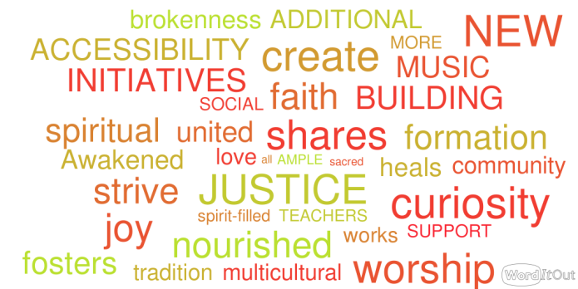
We encourage you to find your current level of commitment on the Fair Share Giving Guide and to think aspirationally about how you might deepen that commitment over the next few years.

