THE MEETINGHOUSE NEWS
  - First Parish in Cambridge, Unitarian Universalist
May 2019

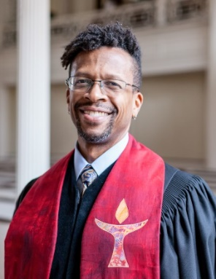
Shared Ministry Weekend, Friday, May 31–Saturday, June 1
On Friday, May 31 we will be working with Rev. Carlton Elliott Smith from the UUA to host a “Shared Ministry Weekend.” Often UU ministers will have a “start-up” weekend when they begin their ministry with a congregation but as we are already at the end of my second year, we are looking at this as an opportunity to look forward as well as exploring where we have already come. Through a combination of targeted conversations with specific congregational leaders and the broader community, we are hoping to help me shape my work in such a way that it truly serves the congregation.

On Friday, May 31 we will have a fellowship meal followed by discussion and goal setting for our work day the following day. We will also have time for reflection about past ministries of the church. On Saturday, June 1 we will dive into some more specifics about goals and expectations, identities and ways of holding community. We are still developing the agenda for the two days, but I am hoping that this can be a rich and productive time for us to plot out some of our work and ways of being together.
If you are interested in helping to coordinate this important gathering, please reach out to me directly. In particular, having some help to organize the meal on Friday (simple soup or chili potluck) and snacks for Saturday would be wonderful. Email me directly (adyer@firstparishcambridge.org)

I will be sharing more information as our plans come together, specifically about who will be needed for specific parts of this process, but my hope is that regardless of whether everyone can attend, we can all benefit from it in the long run.
(The following is an older article, but it still gives some context to the “start-up weekend” - https://www.uua.org/interconnections/56577.shtml)

RELIGIOUS EDUCATION CORNER

BIG ROCKS
This spring has been a time of visioning with the RE Council and the staff team. Working with the “Think Orange” Family Ministry model, RE Council is working towards a balanced yet streamlined set of goals. “Think Orange” uses a visual metaphor for goalsetting: if you want to fill a jar with sand *and* big rocks, in order to meet your priorities, you have place the big rocks (your overarching goals) in the jar first. We developed a set of these overarching goals for the coming year based on input from parents/guardians, children and youth, and teachers, as well as looking at emergent trends in Family Ministry.

We plan to expand this process in the fall to have each teaching team set age-group goals for the coming year. The teams will create developmental goals that build a sense of group identities and help families clearly understand our hopes and plans for each group of children and youth. We will use the RE Council’s “big rocks,” our common goals, to set the stage for this process.

For more about “Think Orange,” please visit http://thinkorange.com.

Religious Education Goals 2019-2020
Exploring morals and values through sacred concepts, texts,
and our Principles and Sources;
Fun that engages children through active learning; and
Creating a healthy, bonded, and inclusive community.
-----------------------------------------------------------------------------------------------------
Parent/Guardian Survey
We’re seeking your feedback on the year and want to hear about your hopes for the topics of our short spring 2020 programs for elementary school. Please help us shape next year's programs! Fill out our short survey here:

https://forms.gle/YCRU9KiX6fvyhVp1A
-----------------------------------------------------------------------------------------------------
Mt. Auburn Cemetery Field Trip
Sunday, May 12
Please join us for a beautiful exploration of Mt. Auburn Cemetery this month. Mt. Auburn was the first American experiment with gardenscaping in a cemetery, and remains a gorgeous destination in spring for birding. Did you know, in addition to migrating songbirds, it is also full of our Unitarian and Universalist ancestors?

Our artist with work currently on display in the Meetinghouse, Dan Wells, will be teaching and demonstrating nature photography. Children can also participate in a scavenger hunt for the gravesites of Hosea Ballou, Fannie Farmer, Buckminster Fuller and many more as they learn about figures from our own religious heritage.

Transportation will be by bus. To sign your family up, please email mneff@firstparishcambridge.org.

JOIN US ON MAY 1
The Environmental Justice Task Force invites you to join us for a book reading with Stephanie Kaza on Wednesday, May 1st at 7:00 p.m. in the CHAPEL. Stephanie Kaza is a practicing Zen Buddhist and pioneer of Green Buddhist thought. She was a professor and program director of Environmental Studies at the University of Vermont. She currently lives and works in Portland, OR, and is a member of the First UU Church there. She will explore with us challenging issues in climate, sustainability and humanity through her two books - Green Buddhism: Practice and Compassionate Action in Uncertain Times; and Conversations with Trees: An Intimate Ecology.

A Chance to Share Your Opinion

Each time I enter the 3 Church Street foyer, I am struck by the many gender-binary signs. They adorn doors and walls and protrude into the foyer on ceiling-level signs. I always feel that these MEN and WOMEN signs send the wrong signal about First Parish. I’m proud that we belong to a congregation that is welcoming to all. That reflects a value I treasure and is one of the reasons I attend and support First Parish.

Are we living up to our values?

The majority of our bathrooms -- two of three on the first floor, two on the landing, and one on the mezzanine level -- are single occupancy. The third on the first floor contains two stalls.
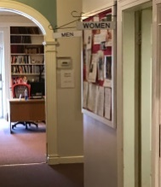
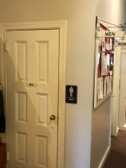
One of those three first-floor bathrooms is labelled ALL-GENDER, as are those on the landing. The second is designated MEN; it does not have a urinal. The third, the one with two stalls, is designated WOMEN.

Privacy is provided in every one of our bathrooms, either by single-occupancy status or by stalls.

I’d like them all to be designated ALL-GENDER. Why don’t we make the foyer reflect the values we hold dear? Designating all of our bathrooms this way and ditching the Men and Women signs would do that and signal to our visitors that First Parish is a special place -- all are welcome here.

What do you think? I will compile your responses and publish the results.

Linda West
westlinda74@gmail.com

First Parish 2019 Retreat
On Saturday, June 8, everyone at First Parish is invited to Salisbury Beach State Reservation (a state park) for fun, food and socializing! To provide the experience you want, please take our quick and easy electronic survey.
We have the exclusive use of a large covered pavilion all day. The 16 picnic tables should provide plenty of seating. There is a small beach on the river and a much larger beach on the ocean.
Activities: We hope to have multiple activities. Which activities will depend largely on who volunteers to lead them and the survey responses. When you take the survey, please let us know both how you would like to spend the day and what you are willing to lead.
Food: Results of the electronic survey and preferences stated during Social Hour on April 21st and 28th will determine whether this will be a pot-luck or a day where food is served (for a fee). In any case, we hope people will bring along snacks to share over the course of the day.
Transportation: The planning team wants to help set up car-pools for the convenience of all involved. More about that closer to the time.
Note: There is a $14 parking fee per car with a MA license plate. (If the driver is 62 or over, a lifetime pass is $10 and can be purchased at the park.)

Accessibility: The beaches and restrooms are accessible.

In summary we suggest that you:
- Complete the survey soon so we can plan around your preferences.
- Check out the park website for a more complete description of the facility:
https://www.mass.gov/locations/salisbury-beach-state-reservation
- Plan to come and join your friends at First Parish for a day at the beach!

Shared Offering for May
Our recipient for May is the Greater Boston Interfaith Organization. GBIO is a 20+ year old organization that educates, advocates, and uses power to implement social justice and racial equity in our region. Its accomplishments are legion: criminal justice legislation adopted; funds for affordable housing in Boston approved; a STEM high school in Roxbury built; and health care laws enacted.
The current priority is on additional health care reforms including dealing with mental health, cost containment and better access including to children of immigrants. Equally important, GBIO has recently voted to approve a “radical reshaping” of its organization to bring in congregations comprised primarily of people of color and immigrants.
First Parish Church became a member in October 2015 and is a very active participant.

Mother’s Day Walk for Peace
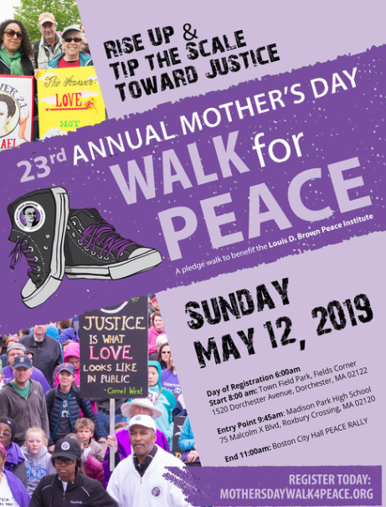
First Parish comes together to support the Louis D. Brown Peace Institute by walking across Boston as part of the Mother’s Day Walk for Peace.
Sign Up Now to Walk and/or to Donate at this link https://lbdpeace.z2systems.com/fpcambuu
That will bring you to the First Parish Cambridge page where you can register and donate. All walkers must register. Registration cost this year is $10 per walker, however no one will be turned away for lack of funds. When you register, be sure to select First Parish CambridgeUU as your team. At the end of your registration there will be an opportunity to donate.
Can’t do the walk? You can still donate on our page. You may also donate through the church by writing a check payable to First Parish and write “Walk for Peace” in the memo line. If you have any questions about registering or donating, either come to our table in Social Hour or contact Chris McElroy at cmcelroy52@gmail.com. All details on the walk are available at mothersdaywalk4peace.org
The Mother’s Day Walk for Peace has been gathering those affected by gun violence and their supporters for 23 years. Join us on Mother’s Day to demand both an end to this violence and dignity and compassion for all families impacted by murder.
The Mother’s Day Walk is also the Peace Institute’s most important fundraising event. They’re asking us to invest in community-based solutions to a complex problem. In 2019, their goal is to raise $400,000 for our critical programs and services.
Invest in peace this Mother’s Day - Sunday May 12, 2019
The Mother's Day Walk for Peace started in 1996 so families of murdered children and young people could receive support and love from their neighbors. It is a center for healing, teaching, and community organizing. It provides vital crisis management, counseling, and funeral and burial assistance to family members of homicide victims.

MINISTRY TEAM UPDATES

Fire of Commitment Team
As we welcome May, our team thanks all who have made financial commitments to support First Parish’s programs and ministry. During March and April you stepped up to empower our congregation!

So far, commitments total over $247,000!

We reached 82% our dollar goal for the campaign -- $300,000 – but there’s still room to grow. We need your help to reach our goal and sustain our ministries.

We look for 100% of congregation members to commit to give what they can. Every gift is valued. Every gift, no matter its size, is a way to express what our community means in the giver’s life.

If you have not yet made a financial commitment this year, make one now on our Fire of Commitment Page.

With gratitude,
Fire of Commitment Team: Linda Clark, Karin Lin, Linda West

GBIO Health Care Campaign at First Parish!
- Are you or someone close to you struggling to pay for necessary medicines or other health care?
- Have you or someone close to you suffered from mental health problems and not received the help you or they need?

On MAY 19 at 12:15 in the Barn Room, come share your stories and learn about the campaign. Last year Greater Boston Interfaith Organization held hundreds of small group discussions across our 45 congregations, including First Parish, to help plan our agenda for change in 2019. We identified four issues that need action to improve health care in Massachusetts: High Cost of Prescription Drugs; High Out of Pocket Costs; Mental Health Care; Health Care for Immigrant Children. For more information about the event, contact Marcia Hams (marciahams@gmail.com) or Tod Hibbard (hibbard79@gmail.com).

The Music Team
Mark Your Calendars for Gospel Sunday!
The Music Team is pleased to announce the return of Linda Brown-San Martin to lead another Cambridge area gospel choir at First Parish on Sunday, June 16. All who love singing are invited to participate, along with the First Parish Choir. Spread the news to neighbors, family and friends! Rehearsals will be held on Thursday evenings, May 30, June 6 and June 13, with a dress rehearsal on Saturday, June 15. More details will follow. If you are interested, please contact Music Director Jonathan Barnhart after worship, or at JBarnhart@firstparishcambridge.org.
Religious Education Council
Our Religious Education Ministry is building our 2019-20 teaching teams now!

We especially need help with our 2-3rd grade/homeschool equivalent, who will be using the Moral Tales program. Moral Tales attempts to provide children with the spiritual and ethical tools they will need to make choices and take actions reflective of their Unitarian Universalist beliefs and values. It uses stories from the world's religions, Faith in Action projects, and crafts as a springboard to help children explore Unitarian Universalist values and experience an openness to our Sources. The Gems of Goodness Project encourages them to recognize, document and tell the group about acts of goodness and justice that they participate in between sessions.

You can see lesson plans here: https://www.uua.org/re/tapestry/children/tales
For more information about the team or to volunteer, please contact Julia Gallogly at juliagallogly@gmail.com.

Cambridge Forum
May 22, 2019, Wednesday, 7:00 PM in the Meetinghouse
Cambridge Forum and Harvard Book Store welcome two-time Pulitzer Prize-winning author DAVID MCCULLOUGH for a discussion of his latest book, The Pioneers: The Heroic Story of the Settlers Who Brought the American Ideal West.

Community Building Fundraising Event
TRAVELERS: An Evening of Storytelling
Friday, May 17 at 7:00 pm
Come and hear real-life stories from some of your fellow parishioners and enjoy an evening of community and entertainment!
Featuring our All Star Cast: Laura Heath-Stout, Susan Shepherd, Grey Lee, Mandy Neff, Valerie Fullum, Rashid Shaikh, Larry Childs and more!
Light refreshments at intermission - Tickets: $12 in advance; $15 at the door
ADVANCE TICKETS May be purchased by contacting the church office or by following this link (https://www.eservicepayments.com/cgi-bin/Vanco_ver3.vps…) and clicking on STORYTELLING EVENT
GREEN PRACTICES: TUESDAY MEALS IS COMPOSTING

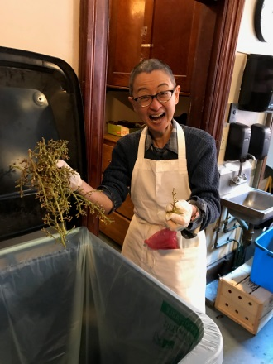
“Oh, happy day!” Tuesday Meals volunteer Cathy Lee was delighted when she spied the compost bin in the kitchen, “I won’t have to haul organic material home in my shopping cart to compost. That’s great!”

Cathy is one of the volunteers who works Tuesday middays to prep the evening meal, which might mean cutting up and preparing mountains of vegetables for salad or side dishes. It’s not uncommon for the prep crew to clean and quarter 50 pounds of potatoes, or a whole crate of kale or green beans, creating a smaller mountain of peels or stems to dispose of.

Cathy pitches in with skill and commitment each week, bringing her own (sharp) knife to the task. For months she had been hauling her shopping cart with her to First Parish. After doing her prep work, she used the cart to ferry organic material back home to her Cambridge residential compost bin -- preventing it from going into the trash barrel and then into the landfill.

First Parish and Tuesday Meals were launched into the green practice of composting in January when Carol Lewis arranged for our trash hauler, Republic Services, to drop off a bin for compostables and to pick it up weekly. Carol also ordered compostable hot cups, plates and bowls, and eating utensils for Tuesday Meals, meaning our waste stream output has plummeted.

Concerned about contamination of the compostables, Roland Ellies makes the composting bin available only for Tuesday Meals. Roland said, “We don’t want people dropping non-compostable stuff in the bin. Then the whole thing would have to go in the trash.”

Peggy Lynch, a member of the First Parish Environmental Justice task force, pushed to have us adopt composting. “Wow, this is something EJTF has wanted to get going for the longest time! Now when we are out advocating for green practices, we’ll know that back home First Parish is doing its best to live into its value of nourishing and serving its community.”

While the midday volunteer crew redirects the organic waste from meal preparation, the Tuesday Meals evening serving crew sees that food scraps and the compostable tableware go into the compost bin. It is gratifying to know that First Parish is doing its bit for the future of our Earth.
You can join the Tuesday Meals crew, volunteering on a regular or occasional drop-in basis. Two hour shifts for volunteers are available between 11:00 am and 7:45 pm each Tuesday. If you have a car, you could also volunteer for the bread pickup Monday evening or Tuesday morning. Contact Mike Mennonno to get your name put on the list for the Tuesday Meals “Weekly Heads Up” email list.

2019-2020 Slate of Candidates
The Governing Board’s Governance Advisory Committee is pleased to present our 2019-2020 Slate of Candidates to run for open seats on the Governing Board. The names of our nominees and their candidate statements appear below. Elections will take place at the Annual Meeting on Sunday, June 2, 2019. Please come to the meeting to vote!

The Governance Advisory Committee called for nominations and self-nominations in February and has sought to develop a slate that would foster diversity and broad representation from our membership. We met with interested candidates to be sure they were fully informed of the duties of the position and able to commit to service. Candidates for these positions have learned about the responsibilities by conferring with members of the board. The Board was notified of proposed nominees and approved the proposed slate on April 23rd, 2019.

The following slate of candidates along with candidate statements provide background information about their commitment to First Parish. We believe that these candidates share our passion for the mission of First Parish.

Nominees for the Governing Board

Chair: Gordie Calkins
Preferred pronouns: he/him/his
(1-year term followed by non-voting,
ex officio 1 year term as Past Chair)

When my husband and I moved to Cambridge from New Hampshire, we were sad to leave our UU church in Nashua, but excited about being able to choose from the myriad of options in this area. We wanted a church that felt friendly and was actively engaged in the larger community in meaningful ways. We attended several, and in the end found our home right here in First Parish. The Tuesday Meals Program and newly formed (at that time) partnership with Y2Y, resonated with me and my own passions about homelessness and poverty.

I’m excited about the coming year at First Parish and would like to serve as the Chair. I’m interested in helping with the balancing act of maintaining and improving the ways that the church connects with the larger community and our need to make significant improvements to the infrastructure.

Outside of church I lead a small unit of state government working on homelessness issues, primarily partnering with nonprofit organizations that provide services and housing opportunities. I live with my husband of 15 years in North Cambridge. I enjoy taking photos in and around Alewife Reservation and walking with our wacky Brittany Spaniel, Hope.

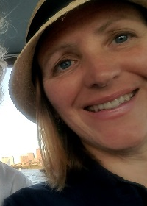
Vice Chair: Gloria Korsman
(1-year term; eligible for 1 year term as Chair)
Preferred pronouns: she/her/hers

First Parish member since 1995, it is my spiritual practice to work and worship together with all of you in our beautiful, covenanted community. I seldom miss Sunday worship, and have served in many leadership roles over the years. In 2016, I worked with the group that drafted our current bylaws and joined the search committee that brought us Rev. Adam. Last fall, I co-facilitated a section of Beloved Conversations, a spiritually focused curriculum for exploring the role of race and ethnicity in individual and congregational lives. I sometimes offer First Parish history walking tours in and around Harvard Square.
I am honored to be nominated to serve as Vice Chair of the Board. I welcome the opportunity to collaborate with the other Board members on mission-centered policies and procedures. If you elect me, I will work hard to fulfill my responsibilities.
I bike all year to church, and to my day job as a librarian at Harvard Divinity School. My wife Kerrie and I live in North Cambridge with our cat Bernard, and near several First Parish members. In my free time, I enjoy gardening, cooking vegetarian food, walking around Fresh Pond, and making things.

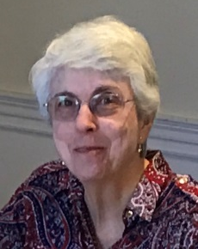

Clerk: Grace Hall
(2-year term; completing 2-year term)
Preferred pronouns: she/her/hers

I am Grace Hall, currently clerk of the First Parish Governing Board. In 2008, I moved to Somerville from Philadelphia to be closer to my daughters and grandchildren. One of my daughters had become a UU a number of years earlier and I had attended services at the Unitarian Society of Northampton. I decided that I, too, would become a UU since I no longer believed the Christian creeds.
First Parish turned out to be what I was looking for and I became a member at the end of 2008. The Sunday morning service is important to me and I have been a member of the Welcome Team for a number of years, including 4 years as Deacon. I was raised in the Middle East (missionary parents) and am co-chair of the Middle East Education Group. I have developed a strong interest in environmental justice and am an active member of the Environmental Justice Task Force. I also was a member of the Finance Committee for several years and served as a facilitator in Covenant Groups for a few years. Overall, my beliefs and my interests match well with the mission of this congregation and I hope to continue as an involved member for many years to come.

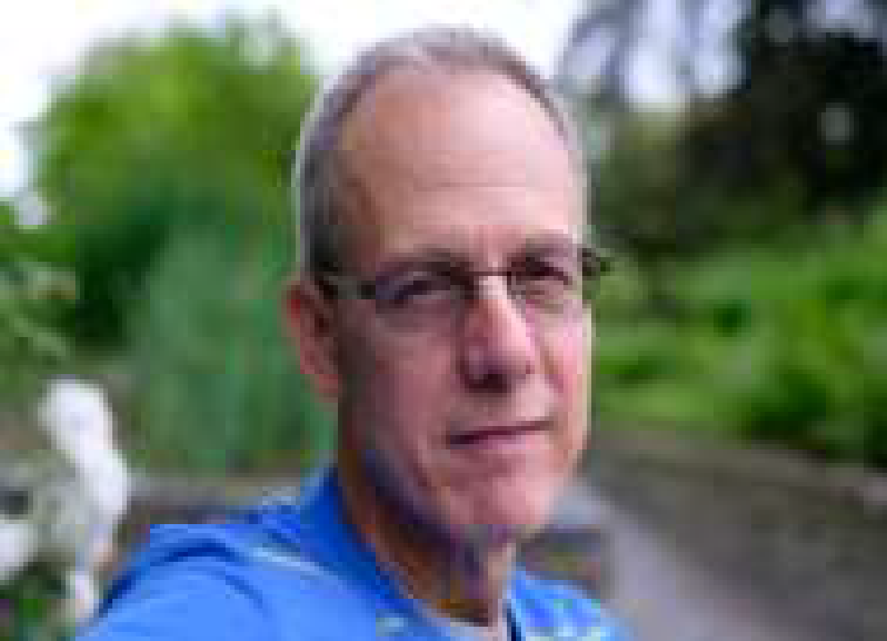

Member at Large: Don Tucker
(2-year term; completing 2-year term)
Preferred pronouns: he/him/his

When I was 12, my mother took me and my siblings to the Unitarian Universalist church in Knoxville, TN, and I’ve been a UU regular since then. My partner Charlene and I joined First Parish in 2012. We were drawn to FPC because of the anti-racism/transformation work. I’m moved and feel a deep connection to the FPC community and greater world through music and the choir. At First Parish I’m challenged to take an honest and close look at myself, and I’ve come to appreciate in a new way the power of worshipping and working together in community. I’ve been most involved in Stewardship/Development, the Investment Committee and the Choir.

I work in fixed income (bond) research at Manulife Asset Management. Hobbies? I dabble in a lot of things, but I’m serious about distance running.

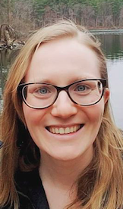

Member at Large: Julia Gallogly
(2-year term; eligible for second 2-year term)
Preferred pronouns: she/her/hers

I began attending First Parish Cambridge in September 2016. Since then, I have been involved in teaching and curriculum planning for religious education, immigration justice advocacy and William’s internship committee.
During the week, I teach elementary school English learners in the Revere Public Schools.
I grew up Unitarian Universalist in Roslindale, one of four sisters who contributed to our church community by babysitting and playing music. I have deep commitment to the broader Unitarian Universalist tradition and faith based activism, as well as connection to other UU congregations through family and friends.
In addition to First Parish, I find a spiritual home at the Sanctuary Boston, an evening gathering focused on group singing and collaborative worship leading.
In this new leadership role, I hope to support the First Parish community in deepening relationships and building resilience for justice work.

Continuing Governing Board Members

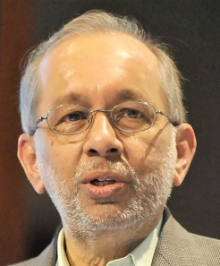
Past Chair: Rashid Shaikh
(Non-voting, ex officio 1-year term)
Preferred pronouns: he/him/his

Treasurer: Cade Murray
(Year 2 of 2-year term; eligible for second 2-year term)
Preferred pronouns: he/him/his

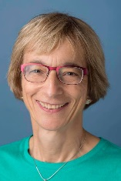

Member at Large: Jan Puibello
(Year 2 of 2-year term; eligible for second 2-year term)
Preferred pronouns: she/her/hers

New Modes of Communication and Getting the Word Out!
We recognize that communicating with members of the congregation and getting the word out about the many activities happening here is important to growing our ministries. Time has shown, though, that the current monthly newsletter does not seem to serve as the best vehicle for such communication. So, the June 2019 issue of The Meetinghouse News will be the last issue of the monthly newsletter in this format. Instead, we’ll be moving to more of a quarterly “theme based” communication. We’ll continue our weekly announcements and email blasts and use these as our main method of alerting people to what is happening around First Parish.
The new quarterly communication will offer opportunities for people to share more personal reflections and include information regarding worship themes and ideas for incorporating new spiritual practices into your life. Watch for more information in the June newsletter or contact Carol Lewis at clewis@firstparishcambridge.org.

GROUPS
Our Elders Group is open and meets on the 1st Tuesday of every month at 2:30 pm in the Chapel. Because of the holiday, this month the group meets on January 8. If you are interested, please contact Rev. Danielle at devminister@firstparishcambridge.org.
Spanish Conversation Group
¿Hablasespañol? First Parish's Spanish Conversation Group meets on first and third Tuesdays of every month at 6:00 p.m. in the Baldwin Room. Come join us for informal conversation in a relaxed, friendly atmosphere. All levels are welcome and no commitment is required! For more information, email spanish@firstparishcambridge.org. ¡Nos vemos pronto!
The Young Adult Group (YAG) is a community for people ages 18-35. YAG meets on the 2nd and 4th Tuesdays at 7pm upstairs in the Nursery and sometimes meets for food and social events on other occasions. Newcomers are always welcome. For more information visit our website cambridgeyag.org

BE SURE TO MARK YOUR CALENDAR
June 2 at Noon
First Parish Annual Business Meeting in the Meetinghouse
The agenda and more details will follow in a couple of weeks.
We hope you will join us as we wrap up one congregational year and
look forward to the next.

