THE MEETINGHOUSE NEWS
  - First Parish in Cambridge, Unitarian Universalist
February 2019

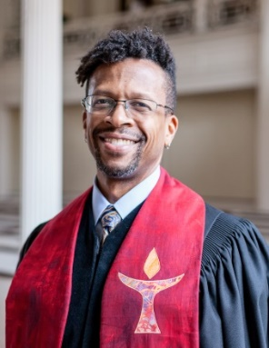
Greetings First Parish in Cambridge!
As we enter Black History Month, I want to share a list of names, places and accomplishments with you all. This is excerpted from Mark Morrison-Reed’s book Revisiting the Empowerment Controversy: Black Power and Unitarian Universalism:

“From the beginning, black founders and leaders were making their mark on Unitarianism and Universalism.

• (1785) Gloster Dalton, a black man who had been born in Africa, was a signatory at the founding of John Murray’s Universalist congregation in Gloucester.

• (1801) Amy Scott was one of the incorporators of the First Universalist Society of Philadelphia.

• (1860) Rev. William Jackson testified to his conversion to Unitarianism at the fall conference of the American Unitarian Association in Bedford, Massachusetts, but was turned away.

• (1871) Six years after the founding of the National Unitarian Conference, Peter H. Clark attended, representing the First Congregational Unitarian Church of Cincinnati.

• (1887) John Bird Wilkins founded the People’s Temple Church (Colored Unitarian) in Chicago.

• (1892) Joseph Jordan founded a Universalist Church in Norfolk, Virginia.

• (1908) Lewis Latimer was a founder of the Unitarian Church of Flushing, New York.

• (1908) Rev. Powhatan Bagnall was granted fellowship by the AUA and established a community ministry to “colored people” in Greater Boston.

• (1920) Rev. Ethelred Brown founded the Harlem Unitarian Church.

• (1932) In Cincinnati, William H. G. Carter founded the Church of the Unitarian Brotherhood.

• (1948) Lewis A. and Marcella Walker McGee helped to found the predominantly African American Free Religious Fellowship on South Side Chicago and Lewis McGee served as its first minister.

• (1955) James Cunningham, MD, was the founding president of a fellowship in Sitka, Alaska.

• (1956) Errold D. Collymore was elected to the American Unitarian Association Board.

• (1960) Sylvia Lyons Render was a founding member of the Eno River congregation and first secretary of its Board.”

And there are more. I encourage you this month to explore these stories. Know this history. Black History is Unitarian Universalist History.
Rev. Adam
RELIGIOUS EDUCATION CORNER
Summer is a wonderful time for immersion in week-long programs that help your child grow in faith - building positive community, learning and expressing values, worshipping, and having outdoor fun and joy! Many members of our community participate in General Assembly and Ferry Beach Religious Education Week. Here are some links to explore those and the many other summer opportunities to dive deep into Unitarian Universalism!

Unitarian Universalist Summer Opportunities for All Ages

UUA General Assembly
(All ages)
General Assembly is the annual gathering and business meeting of Unitarian Universalists all over the country. This year’s General Assembly (or “GA) will be held from June 19th – 23rd in Spoken, WA. The theme for this year’s GA is “The Power of We”. GA is filled with workshops, inspiring worship services, opportunities to learn more about the business of our denomination, an amazing exhibit hall, and social justice and witness opportunities. There are also programming opportunities for children at General Assembly. www.uua.org/ga

Youth Caucus: General Assembly also has a youth caucus for youth ages 14-18, with social support and programming provided specifically for youth. Information can be found here: http://www.uua.org/re/youth/events/gacaucus/

Unitarian Universalist Camps
(Ages 8-19, some may also offer adult or family camps)

Ferry Beach is located in Saco, Maine, Ferry Beach has week-long programming for families and people of all ages. In particular, you might check out their Religious Education week, Youth Camps, and Family and Friends week. https://www.ferrybeach.org/conferences.html

Rowe Camp is located in Western Massachusetts, Rowe offers one to three-week long age specific summer camps for youth ages 8-19. http://rowecenter.org/wp/summercamp/

Star Island is located off the coast of New Hampshire and offers several family weeks.
https://starisland.org/programs/

Unirondack is located in New York’s Adirondack mountains, Unirondack offers one-week summer camp experiences for youth ages 9-18 and a week of family camp. https://www.unirondack.org/programs/

Youth Opportunities
(High school youth)

General Assembly Youth Caucus, June 19th – 23rd, Spokane, WA (see above)
http://www.uua.org/re/youth/events/gacaucus/
Unitarian Universalist College of Social Justice
The UU College of Social Justice hosts several transformative programs for high school aged youth, including justice trainings near General Assembly, and longer programs in New Orleans, Boston, and the Southwest Border.
http://uucsj.org/youth/

Summer Seminary
Summer Seminary is a program for Unitarian Universalist youth exploring the possibility of becoming a religious professional. Summer Seminary 2019 will take place at Iliff School of Theology in Denver, CO on July 23-29, 2019. https://www.uua.org/youth/events/summerseminary

THRIVE UU Youth and Young Adults of Color Multicultural Leadership School
The Multicultural Leadership School (MLS) is a training designed specifically for Unitarian Universalist (UU) Youth and Young Adults of Color to equip them to be leaders in their UU congregation, district or continental committee. 2019 Thrive Youth will be held on July 17-21, 2019 at First Universalist Church of Minneapolis, MN.
https://www.uua.org/youth/events/multicultural-leadership-school

Young Adult Opportunities
(Ages 18-35)
UU College of Social Justice 2019 Global Justice Summer Internships
We offer summer internships for emerging young adults (ages 18-25) who wish to deepen their engagement with social justice and discover new ways to put their faith into action.
https://uucsj.org/calendar/?date1=2019

THRIVE UU Youth and Young Adults of Color Multicultural Leadership School
https://www.uua.org/young-adults/events/thrive

Shared Offering for February

Our recipient for February is NAMI (National Alliance on Mental Illness) Massachusetts. Since 1982, NAMI Mass has been the pre-eminent force in Massachusetts to improve the quality of life through education, training, support, and advocacy, for the one in five people in our state with mental health conditions – and their families and caregivers.

They seek to extend the education, support, and advocacy programs of NAMI Massachusetts so that they will reach out to all Massachusetts consumers and their families; improve the public’s awareness and understanding of mental illnesses; and advocate at all levels to ensure that all persons affected by mental illnesses receive, in a timely fashion, the services that they need and deserve.

NAMI Massachusetts is committed to programs that are both peer and family-driven; to the key concepts of recovery, resiliency, and support that are essential to wellness and quality of life; and to full and meaningful lives for all persons.

MINISTRY TEAM UPDATES
Members of Beyond Borders/Sin Fronteras joined MIRA (Massachusetts Immigrant and Refugee Advocacy Coalition) at the Boston Women's March on January 19, 2019. MIRA is supporting the Safe Communities Act, which is before the Massachusetts legislature. Text SAFEMA to 52886 to join the campaign.
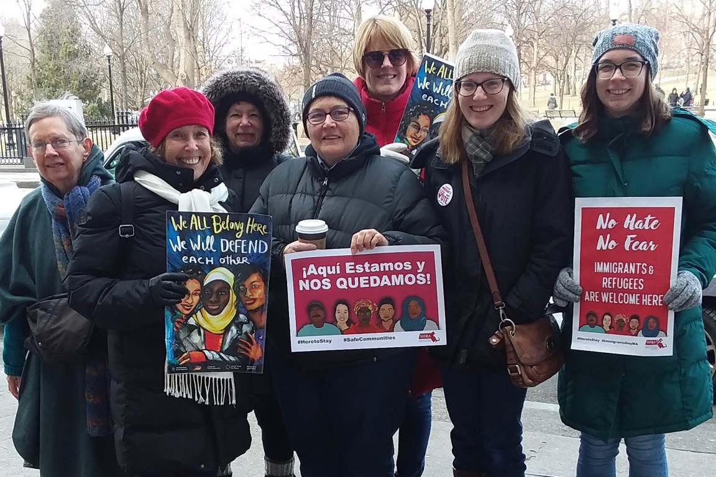

Membership Team
First Sunday Pot Lucks: All are invited to attend a pot luck lunch after the service on Sunday February 3rd. New comers are especially welcome to this event as a way to get to know each other better and to meet more members of the congregation. Bring a dish either from home or pop around the corner and get a pizza or other food item and join us for fellowship. The lunch will start about 15-20 minutes after the service in Parlor. The kitchen oven and fridge are available if needed. Plates, silverware, napkins, cups, serving utensils, and tables and chairs will be provided. Please contact John Shaw (js@jfds.net) if you are interested in coordinating. Otherwise, just show up!
Hospitality Team: Isn’t it nice to have snacks and hot beverages after worship services? We have been trying to keep the social hour hospitality flowing and have assembled a small group of regular contributors to bring in goodies to share. You could too! We welcome folks to sign up for a Sunday to help out. It’s a great way to practice generosity and abundance. Contact Victoria Rowe (victoria2626@gmail.com) if you would like to sign up and get an orientation.
The Middle East Education Group

Being Queer in Palestine – Solidarity Across Borders.

The Middle East Education Group and the Cambridge Bethlehem People-to- People Project invite you to a coffeehouse presentation and discussion on Friday, February 8, 6:30-9:00pm in the Parlor.

Presenter is Sa’ed Atshan with remarks by Abe Rybeck. Sa’ed is Assistant Professor - Peace & Conflict Studies at Swarthmore College and a LGBTQ Palestinian human rights activist. Abe is a local activist and also Founder/ Artistic Director of The Theater Offensive, a grassroots movement and voice for the LGBTQ community raising awareness, and fighting bigotry and hate through the performing arts. Free and open to the public. Please RSVP, as space is limited. bethflehemcambridge@gmail.com.

Racial Equity Team
"White Supremacy Culture" - Sunday, February 24, 2019 12:15pm-1:45pm, in the Chapel
Please join the Racial Equity Team for a light lunch and discussion of "White Supremacy Culture" - a short (8 page) article by Tema Okun found here. Please read and reflect on the article in advance of the discussion. Questions? Contact Charlene Galarneau at charlene.galarneau@gmail.com. If you plan to attend, we'd appreciate knowing ahead (for food estimation), please email Charlene by noon, Friday, February 22. Even without advance notice, you are most welcome on the 24th.

From the Giving Team

WHAT IN THE WORLD IS A SUSTAINER?
Our December Meetinghouse News article, which urged streamlining the process of giving, elicited a number of questions, which we hope to answer here.

DEFINE SUSTAINERS
Members of the congregation who have made known (to the office) their commitment to give a designated amount each year into the future -- until they say “Stop” or “Change.”

That amount may be small or large, given in one chunk or in multiple payments. The amount or periodicity is not the point. That First Parish can count on the support without asking again is.

LIFE IS ALWAYS CHANGING -- HOW CAN I MAKE SUCH A COMMITMENT?
Figure out a donation amount that you feel confident you can afford and let First Parish know you will give that annually. In any especially good year, or when you are feeling especially grateful, you can always give more.

I MADE A MULTIYEAR COMMITMENT A WHILE AGO -- ISN’T IT STILL GOOD?
In 2016, a number of members made two-year commitments to support Rev Adam’s first couple of years with us. Guess what? He’s been here almost two years now. Please extend your commitment by making a new one.

HOW DOES A CONTINUING COMMITMENT HELP?
- It saves you time and energy: there’s no need to do anything from year to year unless you want to change your commitment.
- It saves time and energy on the part of staff and volunteers: during the spring annual fund drive they won’t have to contact you or any of the others who’ve made such commitments.

OK, I CAN DO THAT. HOW DO I SIGN UP?
Click here: https://tinyurl.com/ybmar4e9

A very wide range of ability to contribute financially is represented among families and individuals who make up the First Parish community. Given this range, we encourage member of the congregation to give what they can.

Congregational Giving Team
Linda Clark, Karin Lin, Linda West

GROUPS
Our GBLTQ-I covenant group is open. This vibrant group meets on the first Wednesday of every month. If you are interested in this group, please contact Rev. Danielle at devminister@firstparishcambridge.org.

Our Elders Group is open and meets on the 1st Tuesday of every month at 2:30 pm in the Chapel. Because of the holiday, this month the group meets on January 8. If you are interested, please contact Rev. Danielle at devminister@firstparishcambridge.org.
Spanish Conversation Group
¿Hablas español? First Parish's Spanish Conversation Group meets on first and third Tuesdays of every month at 6:00 p.m. in the Baldwin Room. Come join us for informal conversation in a relaxed, friendly atmosphere. All levels are welcome and no commitment is required! For more information, email spanish@firstparishcambridge.org. ¡Nos vemos pronto!
The Young Adult Group (YAG) is a community for people ages 18-35. YAG meets on the 2nd and 4th Tuesdays at 7pm upstairs in the Nursery and sometimes meets for food and social events on other occasions. Newcomers are always welcome. For more information visit our website cambridgeyag.org

Spring Potluck Suppers Open to Guests and New Hosts!
Our fall potluck suppers attracted nearly 60 participants and have been an easy and fun way to get acquainted with others in our community. As promised, we are offering a spring potluck supper for those interested in participating on 4/28, 5/5 or 5/19 including those who have been to one of the fall potlucks. Some of our fall hosts will be participating again this spring but there are opportunities for other hosts to help us be able accommodate everyone who wants to attend.
Hosts: We are grateful to our continuing hosts but we also offer the chance to be a host to others who like to entertain without having to cook! We are looking for hosts who can provide a place for 6-12 guests and serve as a coordinator of the logistics with the understanding that each guest provides a part of the shared meal. Please sign up if you would like to be a host for one or two of the following Sunday evening dates this spring: 4/28, 5/5, 5/19 at https://goo.gl/forms/KnJDQjTyHU7b0nzi2
Guests: Everyone who signs up as a guest will be able to attend one potluck this spring – for each event, guests are selected at random. So those who participated in the fall will have a chance to meet new people this spring to make things interesting. Whether or not you want to be a host or a guest, we hope you will put these dates on your calendars now so that you can participate in this year’s potlucks with fabulous food, fun and making new friends! Sign up here: https://goo.gl/forms/85mQzhkGP9qeiImi2
Our theme this year is “Connection.” The Potluck Team -- Valerie Fullum, Linda West and Sylvia Wheeler – hope that the opportunity to meet new people at each potluck will encourage everyone to take advantage of this enjoyable way to expand your connections and make new friends at First Parish.

Call for Governing Board Nominations

The following positions on the First Parish Governing Board will be elected for the 2019-20 fiscal year. The Governance Advisory Committee is seeking nominations from the congregation by Friday, February 22, 2019 for candidates who may be interested in serving in these positions.
Chair: l-year term
Vice Chair: 1-year term
Clerk: 2-year term
At Large Member: 2-year term

2018-19 Governing Board Members and Terms are:
  - Chair: Rashid Shaikh (1 year term)
  - Vice Chair: Gordie Calkins (1 year term)
Past Chair: Linda West (1 year term)
  - Clerk: Grace Hall (Year 2 of 2 year term; eligible for second 2 year term)
  - Treasurer: Cade Murray (Year 1 of a 2 year term; eligible for second 2-year term)
  - Member at Large: Robin Brown (1-year fill-in term; eligible for two 2 year terms but has chosen not to run for another term)
  - Member at Large: Jan Puibello (Year 1 of a 2 year term; eligible for second 2 year term)
  - Member at Large: Don Tucker (Year 2 of 2 year term; eligible for second 2 year term)

The Governance Advisory Committee seeks broad representation of the congregation and to maximize diversity. Members engage with staff, ministry team leaders and board members to identify individuals who have demonstrated reliability in their involvement in congregational activities, a willingness to embrace the responsibilities of service on the governing board and enthusiasm for the shared ministry of working together toward the fulfillment of our mission.

If you would like to consider serving in one of these positions or have a candidate you would like to have us reach out to, please contact one of the Governance Advisory Committee members:
Robin Brown, rbrown450@gmail.com
Gordie Calkins, gordiecalkins@yahoo.com
Linda West, westlinda74@gmail.com
Sylvia Wheeler, sjwheeler1@comcast.net

PAINE SENIOR SERVICES

MISSION: “Paine Senior Services (PSS) is committed to providing a wide range of quality personalized services to Cambridge seniors, regardless of their financial means. In a spirit of compassion and justice, PSS offers counseling, advocacy, and collaboration with community resources.”
Paine Senior Services would like to thank the following people for their generous donations to Paine Senior Services over the past year

Elizabeth Aguilo, in loving memory of her parents and of Kay McDonough
Vincent and Dorothy Albergo
Anonymous (3)
David Aptaker
Avidia Bank
James Baptista, in memory of Esther Foster
Amy Bernstein
Sheila Borges
Janet Burns
Robbie Burstine and Louis A. Rodrigues
Donald and Marianne Crane
Lisa Dobberteen
Frank Duehay and Jane Lewis, in honor of Helen Glikman
Valerie Fleishman
Annie Fowler
Freshpond Trust/Randolph Slaughter
Judith Herman
Bob and Nancy Hurlbut
James Edward Katz, MD
William and Sheila King
Robert Manoff
Chris McElroy
Claudette Nadeau
John and Mary Ellen O’Neill
David Pap
Richard Pendleton
Susan Pendleton
Mark Pickering
Hedy Pocius
Barbara Sweet and
Dorothy Vetter

These donations make it possible to fulfill Paine’s commitment to serve all Cambridge seniors. If you would like more information about the services Paine provides, contact us at 617-864-2580.

Morrison-Reed, Mark D.. Revisiting the Empowerment Controversy: Black Power and Unitarian Universalism (Pages 108 - 109). Skinner House Books. Kindle Edition.

